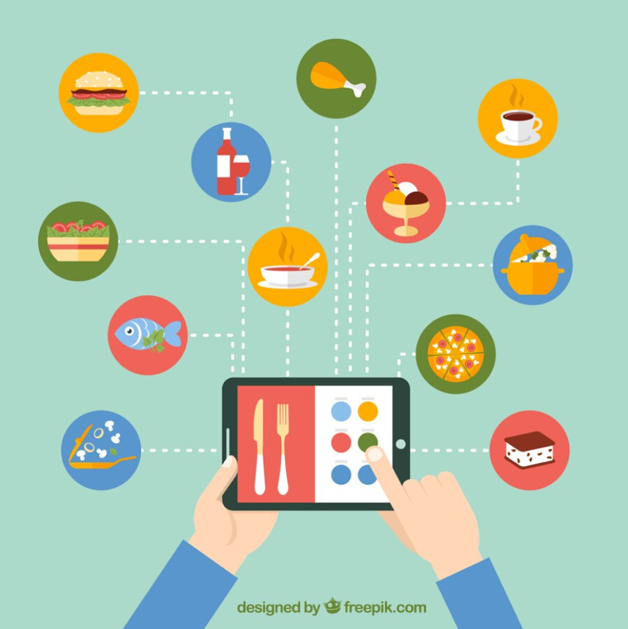

|  |  |
| --- | --- |
| **Team Members** | **Matric Number** |
| Swastik Mishra | G2200524L |
| Prasanthi Ramaswamy | G2202081D |
| Divya Gupta | G2200597K |
| Xia Zhiyang (Michael) | G2201771F |
| Goh Pei Xuan | G2200605C |

**AN6001 GROUP PROJECT BY TEAM 8**

**Restaurantra: Restaurant Recommendation System**

**EXECUTIVE SUMMARY**

Recommendation Engines, nowadays, would be called a customer growth and retention strategy, if not more. Time and again, and across industries the concept has flourished and shaped to drive better sales performance and maintain customer loyalty. Recommendation Engines, defined literally, are the objects created through machine learning protocols wherein the data is filtered in a such a way to recommend most relevant and utility driven items to the consumers. Just as many Machine Learning models, REs are developed on the base of recognising the common patterns involved in consumer purchase behaviour, consumer demographics, product networks, differential pricing, to name a few.

Singapore is considered a sphere where there are multiple options in term of cuisines and people are always willing to try. However due to the fact that there is no central recommendation application in Singapore, most people are left wondering on which cuisine and restaurant they want to explore. This increases their search cost when making the dining decisions and ultimately reduce the satisfaction with the whole experience. Post COVID, even the restaurants are having a hard time gathering business, and an application of a recommendation system can help them target customer based on current trends and preferences in Singapore.

We have designed this recommendation model, keeping in mind both consumers and restaurants want to optimize their demand and supply. With this recommendation system, we are focusing on two key business opportunities:

* **Recommending the similar/familiar cuisines/restaurants to those users which are traditional in nature and generally want to spend less time in deciding where to dine.**
* **Recommending new cuisines/restaurants to the population who are eager to venture out and are explorative in nature**

With the two issues in mind, we aim to help restaurants and e-commerce food giants to effectively price, promote and target when improving current performance or launching new services. Our model uses content- based filtering with TD-IDF Vectorizer and cosine similarity to evaluate which are the recommendations which are the most similar to the consumer’s utility and helping the restaurants understand the current trends, accordingly modifying their marketing spends.

After benchmarking the current work on recommendation engines, a detailed working of the model and visual analysis of our dataset has been provided. The model can be further improved by adding onto sentiment analysis and collaborative filtering, as discussed in the progressive parts of the report.

**TABLE OF CONTENTS**

|  |  |
| --- | --- |
| 1. **INTRODUCTION……………………………………………………………..** | **3-4** |
| 1.1 Background & Literature Review…………………………………………... | 3-4 |
|  |  |
| 1. **BUSINESS SOLUTION……………………………………………………….** | **5** |
| 2.1 Problem Statement………………………………………………………….. | 5 |
| 2.2 Key Deliverables…………………………………………………………… | 5 |
|  |  |
| 1. **DATA DESCRIPTION AND CLEANING…………………………………..** | **5-6** |
| 3.1 Data Description……………………………………………………………. | 5 |
| 3.2 Data Cleaning………………………………………………………………. | 6 |
| 3.2.1 Omitting Irrelevant Variables and Rows………………………… | 6 |
| 3.2.2 Missing Value Treatment………………………………………... | 6 |
| 3.2.3 Data Reorganization……………………………………………... | 6 |
|  |  |
| 1. **VISUALIZATION……………………………………………………………..** | **7-10** |
|  |  |
| 1. **MODEL CONFIGURATION………………………………………………...** | **10-12** |
| 5.1 Content Based Filtering…………………………………………………….. | 10 |
| 5.2 TF-IDF Vectorizer………………………………………………………….. | 11 |
| 5.3 Getting Similar Restaurant Recommendation based on Cosine Similarity… | 12 |
|  |  |
| 1. **MODEL COMPARISON……………………………………………………..** | **13** |
|  |  |
| 1. **BUSINESS IMPLEMENTATION……………………………………………** | **13-15** |
|  |  |
| 1. **EXTENSION OF MODEL……………………………………………………** | **15-17** |
| 8.1 Partnership with Online Giants such as Grab, Food Panda………………… | 16 |
| 8.2 Pricing Strategy or Commission Decisions………………………………… | 16 |
| 8.3 Promoting Cuisines and New Trends………………………………………. | 16 |
| 8.4 Discount on Reservations through System…………………………………. | 16 |
| 8.5 Recommendation on Chain Restaurants……………………………………. | 17 |
|  |  |
| 1. **FUTURE STUDY……………………………………………………………...** | **17** |
| 9.1 Parameter Tweaking.……………………………………………………….. | 17 |
| 9.2 Sentiment Analysis…………………………………………………………. | 17 |
| 9.3 Collaborative Filtering……………………………………………………… | 17 |
|  |  |
| 1. **CONCLUSION………………………………………………………………...** | 18 |
|  |  |
| **REFERENCES…………………………………………………………………………** | 19 |
| **APPENDIX……………………………………………………………………………..** | 20 |

1. **INTRODUCTION**
   1. **Background and Literature Review**

With 48,000 workers in Singapore’s food industry, the industry is worth S$8.3 billion in annual receipts. There is a substantial demand for food and beverage (F&B) within the country (Neo, 2020). This demand could also be observed from the survey conducted by Nielsen in 2018 which revealed that about 20% of Singaporeans dine out daily and almost 70% of Singaporeans dine out for dinner (Ramaswami, 2021). The top three reasons for why more Singaporeans are dining out include convenience, familiarity and time-saving considerations.

For the F&B industry, a growing demand indicates a business opportunity. This attracted newcomers or entrepreneurs to the market so much so much so that the number of F&B establishments in Singapore increased from around 8,500 in 2010 to 13,000 in 2019, presenting a more than 50% increase within the decade (Ramaswami, 2021). The demand however, was dampened by the COVID-19 pandemic which brings with it restrictions in terms of dining out during its initial stages. Even with the relaxation of COVID-19 restrictions, restaurants are hard-pressed to reconsider their business strategy to attract and stand out from the various competitors in the industry sharing the market (Neo, 2020).

Consumers on the other hand, are often spoiled for choices. Rather than taking the time and hassle to look up on what food options are available while being undecided on what to have, most would fall back stall, restaurant or café they frequent (Foodrecce, 2019). This is the most common behaviour of customers in Singapore based on a survey by Deliveroo. From the same survey, there are four main customer personas – Lobang Lucy, Habitual Harry, Indecisive Irene and Adventurous Adam. Each persona has a unique characteristic when it comes to food choices. Lobang Lucy looks out for discounts and deals, Habitual Harry frequent the same familiar eating establishment, Indecisive Irene is unable to decide on what to eat and Adventurous Adam are keen to try out new food choices. All in all, based on the personas of customers, we see that consumers are mostly indecisive hence habitual, to choose the few usual food choices while looking out for discounts (Chevi, 2022). A relatively small proportion of customers are adventurous and willing to try out new cuisine or food type. The graphical representation of the different personas is presented in the figure below *(Figure 1).*

|  |  |
| --- | --- |
|   **Habitual Harry (50%)**  Stick to few familiar establishment |   **Lobang Lucy (42%)**  Spending depends on deals & discount |
|   **Indecisive Irene (14%)**  Unable to decide what to eat |   **Adventurous Adam (5%)**  Open to try out new things |

**Figure 1:** *Different customer personas*

According to the dieticians, such consumer characteristics are especially prevalent in the times of chaos and unpredictability (Bensman, 2021). Eating the same type of food or at the same establishment allows consumers to gain a sense of control. However, such practises have two drawbacks. It leads to food boredom where people grow tired of eating the same food too frequently and consumers are not aware of the other choices available to them (Pogored, 2022). These have implications on both the consumers and businesses. For consumers, while it is desired to still have a sense of control by having the same type of food or cuisine, some form of small changes such as dining ambience, food menu etc. is still desired. For businesses, customers may not have any form of exposure to their food and services, if customers only stick to places they frequent (Seelan & Prabhu,2021).

How can we then satisfy both the needs of consumers who are looking for some form of familiarity yet change and businesses which are constantly on the lookout to expand their customer base?

1. **BUSINESS SOLUTION**

**2.1 Problem Statement**

To match both the needs of customers and F&B businesses, it would be valuable to have a restaurant recommender system – which is able to make recommendations to consumers by matching the list of restaurants within the system with characteristics of the establishment that the consumer currently frequent. An example of the characteristic that we would be examining in our current report is the type of restaurant or cuisine offered by the restaurant. With the advancement of machine learning, it makes it plausible for us to compare and contrast the similarity between cuisines offered by the different restaurants in an automated process and return the findings back to customers in a short span of time. In this sense, customers who are looking for some change to their routine yet have a sense of familiarity in terms of cuisine are exposed possible choices they can choose from. Businesses which are part of the system or programme could potentially reach a wider customer base.

**2.2 Key Deliverables**

For this project and report, we would be using a dataset consisting of information regarding various restaurants sourced from Kaggle, for the building of our recommender system. In the next section, we provide an overview and description of the data that is used, visualisation and cleaning of dataset. Following which, we would present the building of the model through on content-based filtering. A description of how the recommender would be implemented as business solution as well as a mock-up of this recommender would be presented. Finally, we would discuss on how this would be valuable to business stakeholders identified.

**3. DATA DESCRIPTION AND CLEANING**

**3.1 Data Description**

The chosen dataset was obtained from Kaggle, and it reflects information from US based travel company, TripAdvisor. The variables within the dataset are presented below. Further information can be found in Appendix.

|  |
| --- |
| **Name of Variable** |
| Name* |
| Street Address |
| Location* |
| Type* |
| Reviews* |
| No. of Reviews* |
| Comments* |
| Contact Number |
| Trip_Advisor_URL |
| Menu |
| Price Range* |

* - Variables of Interest

**3.2 Data Cleaning**

**3.2.1 Omitting Irrelevant Variables and Rows**

Firstly, the variables reflecting ‘Contact Number’, ‘Trip_Advisor_URL’ and ‘Menu’ have been dropped as they are not important for the model to be built since these are information pertaining to each restaurant in itself.

It can also be seen that there are 2 rows containing no information except for the ‘Name’ and ‘Location’ of the restaurant and hence, these 2 rows have also been deleted.

**3.2.2 Missing Value Treatment**

There are 628 null values within the dataset, mostly pertaining to the ‘Type’ and ‘Comment’ columns. The null values in the ‘Type’ columns were replaced with the mode value (most frequently occurring) of the variable. The missing values in the ‘Comment’ column were substituted with a blank (empty string in python).

**3.2.3 Data Reorganization**

Individual columns were also cleaned up to ensure that the data was represented clearly and succinctly. The commas separating the cuisines mentioned in the ‘Type’ variable were removed. Both the ‘Reviews’ and ‘No of Reviews’ columns were cleaned such that they indicated a single value instead of a sentence. After cleaning, the ‘Review’ column contained a value indicating the average rating given to the restaurant by customers (out of 5). Similarly, the ‘No of Reviews’ columns indicated an integer value reflecting the total number of reviews for the restaurant on the website.

1. **DATA VISUALIZATION**

An exploratory data analysis in the form of data visualization was done. Since the recommendation system is to be built on the premise of the ‘Type’ columns, this is the main variable that has been focused on in the data visualization. These visualizations are useful as a tool to understand some of the underlying trends within the dataset, especially with respect to the types of cuisines offered by restaurants and preferred by customers. It can help restaurants when they set their pricing strategies and description of cuisine whilst registering with the recommendation system.



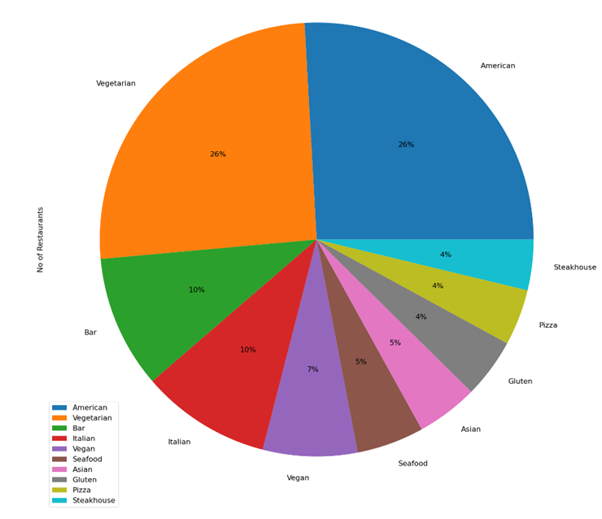

**Figure 2:** Most Popular Types Based on Number of Restaurants

From the pie chart, it is evident that many restaurants offer American and Vegetarian food. Bar and Italian food are the second most offered cuisines by restaurants.

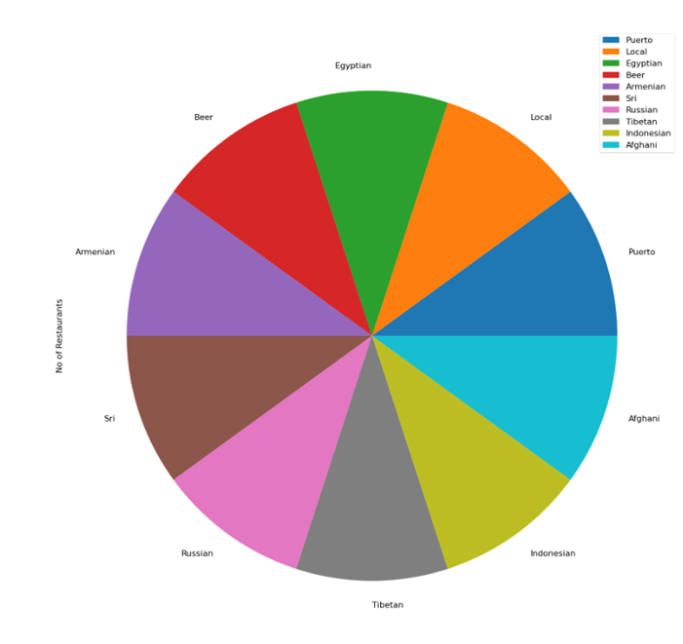

**Figure 3:** Least Popular Types Based on Number of Restaurants

The types represented in the visualization above only have one restaurant offering the type. In order for the recommender to be effective, it is imperative to source for more restaurants offering these types so that there will be more options to choose from. This is to ensure that the recommendation system will be able to provide consumers with more option to choose from.

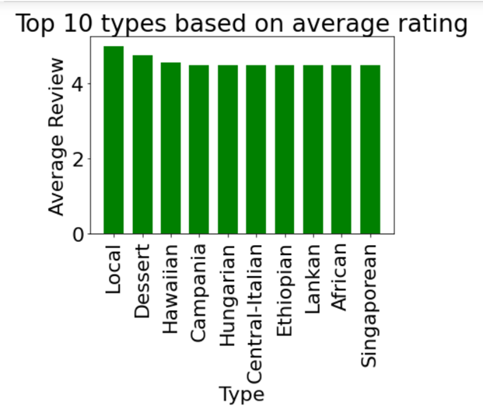

**Figure 4:** Top 10 Types Based on Average Reviews (Out of 5)

Local and Dessert are the highest rated types. This is followed by Hawaiian, Campania and Hungarian food.

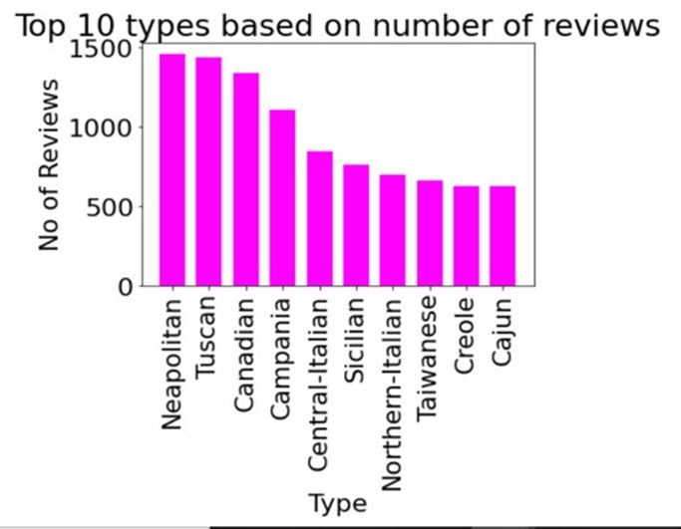

**Figure 5:** Top 10 Types Based on Number of Reviews

The bar graph illustrates that Neapolitan and Tuscan food have the highest number of reviews, followed by Canadian and Campania food. This helps us understand some of the keywords Restaurants may choose to include in the description of their restaurants for optimal search results. For example, if a restaurant sells Italian food, it would help if the restaurant specified the region they represent as their food type.

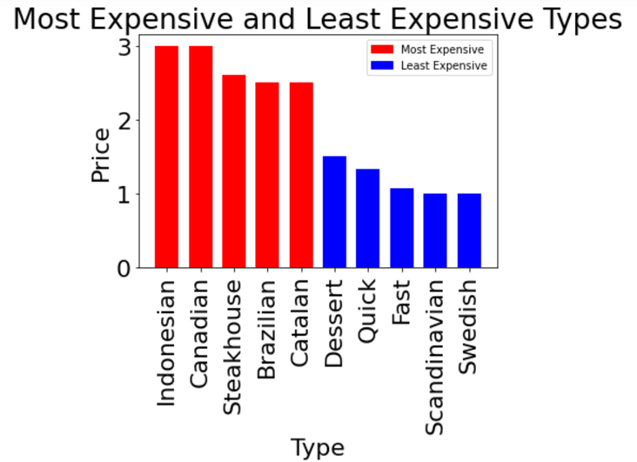

**Figure 6:** Most and Least Expensive Types

Indonesian and Canadian food seem to be the most expensive types whereas Scandinavian and Swedish type offer the lowest priced food. This visualization could serve as a guide for restaurants to set their pricing strategies.

**5. MODEL CONFIGURATION**

To recommend similar restaurants based on type of food served, a model was created using a publicly sourced dataset. The variables included in the model are specified in Appendix A. The model used Tf – Idf Vectorizer algorithm which enabled it to recommend restaurants based on cosine similarity matrix calculated by taking ‘Type’ column into consideration. This type of system is called ‘**Content Based Filtering Recommendation System**’.

**5.1 Content Based Filtering**

This filtering is based on the description, or some data provided for that product. The system finds the similarity between restaurants based on its context or description. In this case context is types of cuisines served in the restaurant. The main idea behind content-based filtering is to try to build a model based on the available features the explain the pattern between similar restaurants.

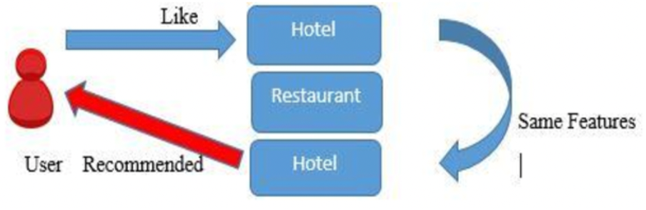

**Figure 7:**  *Content based filtering algorithm*

**5.2 TF – IDF Vectorizer**

TF-IDF is an abbreviation for Term Frequency Inverse Document Frequency. This is very common algorithm to transform text into a meaningful representation of numbers which is used to fit machine algorithm for prediction. TF-IDF works by proportionally increasing the number of times a word appears in the document but is counterbalanced by the number of documents in which it is present. Hence, words that are commonly present in all the documents are not given a very high rank. However, a word that is present too many times in a few of the documents will be given a higher rank as it might be indicative of the context of the document.

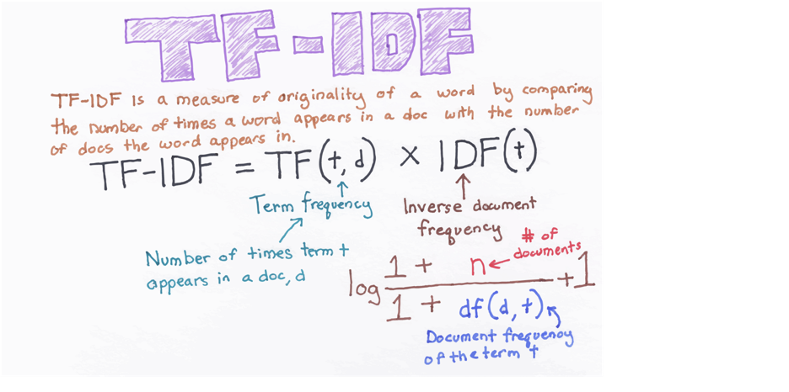

**Figure 8:**  *Explanation and formulae of TF – IDF*

TF – IDF Vectorizer is a combination of Count Vectorizer and TF – IDF Transformer. CountVectorizer performs the task of tokenizing and counting, while TfidfTransformer normalizes the data. TfidfVectorizer, on the other hand, performs all three operations, thereby streamlining the process of natural language processing.

**5.3 Getting similar restaurant recommendation based on Cosine Similarity**

Cosine similarity is a metric used to determine how similar the documents are irrespective of their size. Mathematically, Cosine similarity measures the cosine of the angle between two vectors projected in a multi-dimensional space. In this context, the two vectors are arrays containing the word counts of two documents. The cosine similarity is advantageous because even if the two similar documents are far apart by the Euclidean distance because of the size they could still have a smaller angle between them. Smaller the angle, higher the similarity.

Our model finds the cosine similarity between two restaurants based on their values in column ‘**Type**’. The more similar values they will have the smaller will be the angle and hence the cosine value will be closer to 1.

When we enter the name of the restaurant in ‘**get_recommendation’** function, the function searches for the index value of the input restaurant from the dataset. We then find the top 10 cosine matrix value related to that index and finally display the restaurant names which the top 10 values represent.

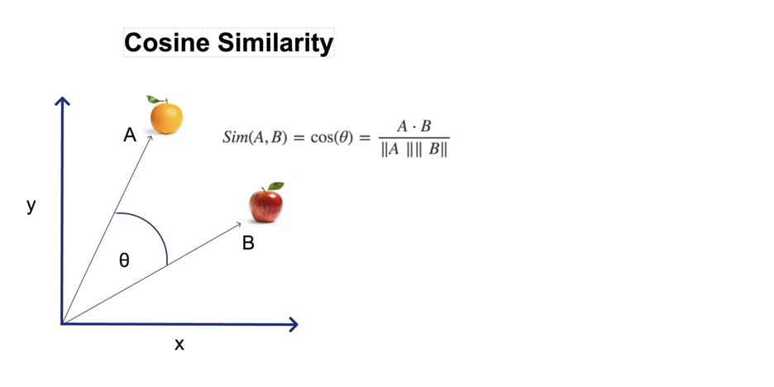

**Figure 9:**  *Figure explaining cosine similarity*

**6. MODEL COMPARISION**

First the project was implemented using TF – IDF Vectorizer model and then another model was built using Count Vectorizer and TF – IDF transformer. Both these models gave the same recommendations because fundamentally TF – IDF Vectorizer is a combination of TF – IDF Transformer and Count Vectorizer. The figure below shows the recommendation made by the two models.

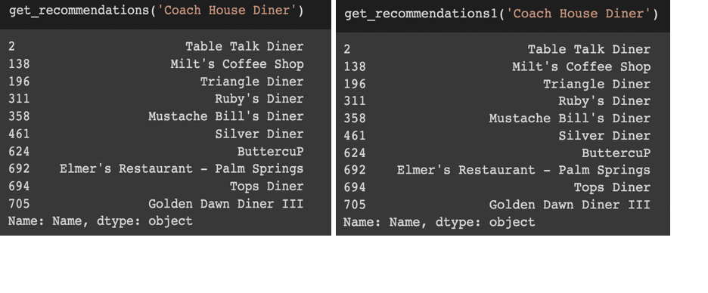

**Figure 10:**  *Figure explaining showing the recommendations by the two models when input is Coach House Diner*

**7. BUSINESS IMPLEMENTATION**

To implement the recommendation system into practice, a webpage demo is created for user to try out the recommendation system, using the streamlit. The webapp has been deployed to heroku and functions well. Please find it at the [main · Streamlit (ai6001-restaurant.herokuapp.com)](https://ai6001-restaurant.herokuapp.com/).  The below screenshot shows the format of the webpage.

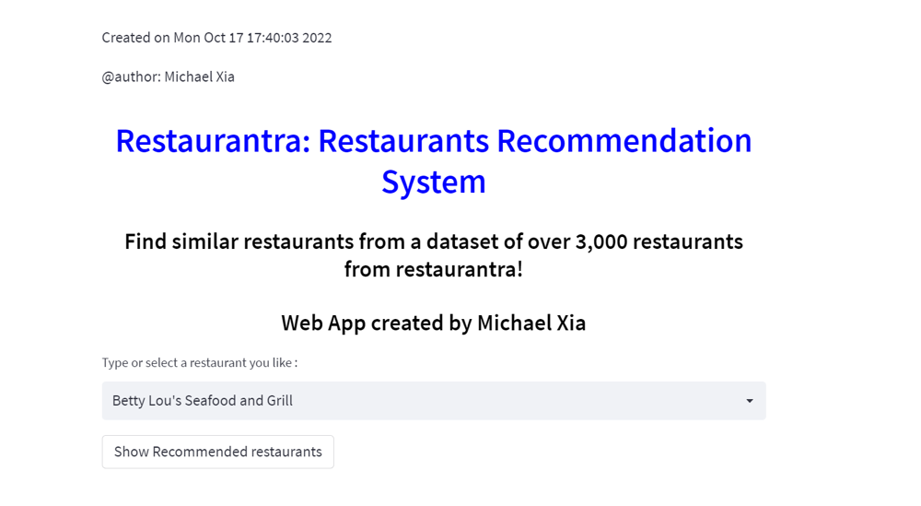

**Figure 11:**  *Webpage Design*

The recommendation system allows the user to choose the restaurant name from the list, or to type the restaurant name in which situation the system can automatically show the similar restaurant names in the dataset. Basically, it recommends the restaurants based on what the users likes in the list or what they search. Once the user has input the name of restaurant and press ”Show Recommended restaurants ” button, the webpage will recommend the five most relevant restaurants to you. The relevancy is based on tags of restaurants including their multiple attributes, including name, location, reviews, types of cuisines and comments. More detailed procedure is explained below.

To build this system, it requires three files, ”restaurants.pkl”, ”similarity.pkl”, which two store the model of recommendation system, and”main.py“which is using streamlit to build the webpage.

Based on these files, we run streamlit file written in python in Anaconda prompt as the screenshot seen below.

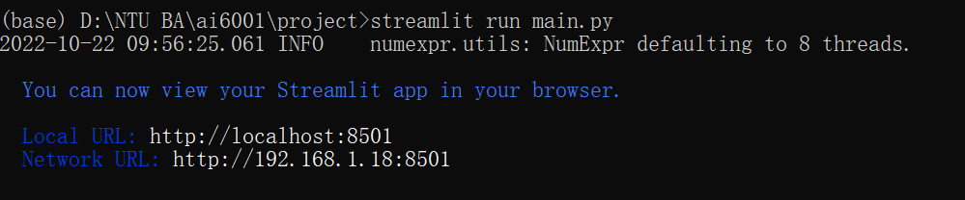

**Figure 12:** *Running streamlit in Python*

The webpage allows user to select a restaurant in the list.

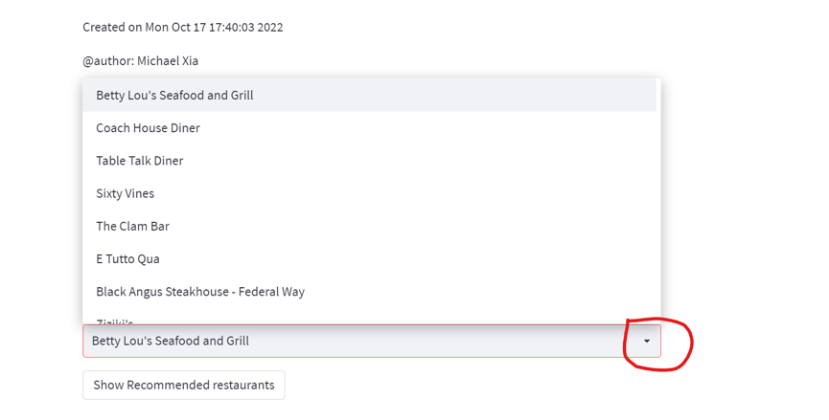

**Figure 13:** *Dropdown list on Webpage*

The webpage also allows user to type the restaurant names and it will show automatically the related restaurants.

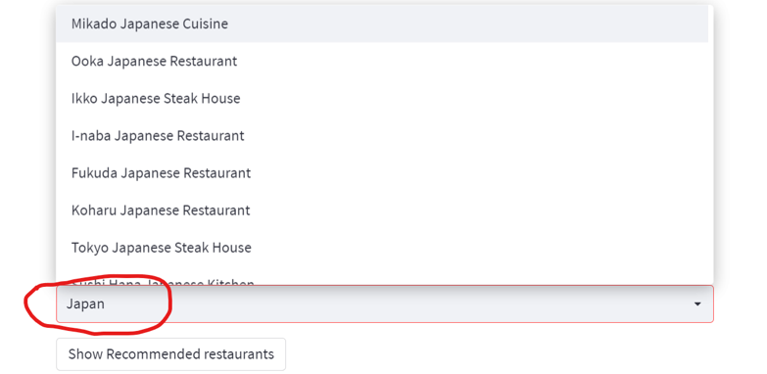

**Figure 14:** *Keying in of keywords on webpage*

After the input, the user can press the button below to see the top five related restaurants.

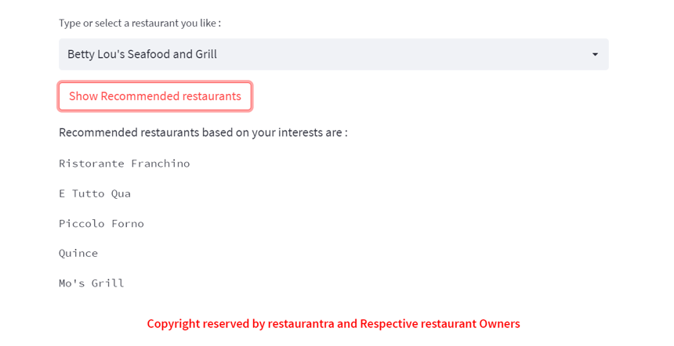

**Figure 15:** *Output of Search*

**8. EXTENSION OF THE MODEL**

With our current model, we focus on content-based filtering of recommendation system, wherein we filter the restaurants which have similar type of cuisine can be recommended to the customer. Recommending restaurants on the basis of the type when the customer enters a certain name helps customer to explore new options serving the same category of food. For constructing this model, we have used cosine similarity matrix to group the similar restaurants by type of food. Such a recommendation system has multiple business extensions in a country like Singapore where most of the times even locals and new population have a hard time finding locations where they would want a specific cuisine. To extend our model, we can think of the following suggestions while solving our business problem at the hand.

* 1. **Partnership with online giants such as Grab/Food Panda**

Food delivery apps such as Grab and Food Panda can serve as a platform to launch this recommendation system. With a huge sphere of e-commerce, consumers generally know what kind of food they want to eat but take hours to settle on the restaurant they want to order from. With using the recommendation system, a consumer can know in a minute, from which restaurant he wants to order food, hugely decreasing the search cost of the purchase. For the food delivery brands, this can result in higher customer satisfaction and may lead to consumer exploring new options which have not been already tried or are new on the delivery platforms. This would translate into seamless food ordering experience for the customer, more customer loyalty for the partners applications and more revenue and new customers for the restaurants itself.

* 1. **Pricing strategy or commission decisions (Partnering with Individual restaurants)**

Another way for the business extension would be partner with individual restaurants and rope them in for a commission. This extension can take the advantage of price differentiation, wherein we can have different commission bands for different cuisines and restaurant types. As Singapore caters to multiple cuisines and there more no of restaurants coming up every day, we can charge a higher commission from high end restaurant in exchange of higher visibility on our recommendation engines. Restaurants are well aware recommendation adds most to their marketing strategy. This can promote consumers to try out the restaurants which are recommended at the top positions. This can be done by ranking the restaurants using a point system and decide the commission strategy for each restaurant we partner with.

**8.3 Promoting cuisines and new trends**

With the help of a recommendation system such as this, we can track the search terms used by each user to gather insights on what are some of the popular cuisines in Singapore and they can be promoted extensively with the support of above-mentioned partners. Similarly, using Search optimisation techniques we can develop an idea what people are searching for the most, what are the new trends and cuisine preferences coming up. This can help in better placement of restaurant recommendation, increasing the customer utility.

* 1. **Discount on reservations through our system**

If the consumers are directed through our recommendation system to a restaurant, they can use a discount/promotion code. Through this system, we can attract more customers and restaurants in terms would have more and new people which would ultimately cover the costs for discounts provided.

* 1. **Recommendation on chain restaurants**

Chain restaurants, such as Japan Food holdings, which have multiple franchises in the city can use the recommendation system to recommend other outlets if one outlet is completely reserved. Additionally, they can target promotions and pricing as per the popularity of each outlet going by popularity on the recommendation system search.

**9. FUTURE STUDY**

With the limited bandwidth in terms of time and resources, we successfully could develop the model based on ‘Type’ similarity to recommend restaurants, however, the model can further be developed and can be layered in the following three ways. They are easy to add on to the current application and tweaked without undertaking much costs.

* 1. **Parameter Tweaking (An extension to Content Based filtering Recommendation System)**

By tweaking the parameters in the cosine similarity matrix, we can build on various filters on the recommendation. We can location, price, ratings etc to make the similarity matrix more extensive and utility focused as per our user demand.

* 1. **Sentiment Analysis**

Sentiment analysis is technique in natural language processing technique used to determine whether a particular text is positive, negative or neutral. It is mostly used to help businesses monitor brand and product sentiment in customer feedback so as to understand their needs. By using this technique, we can define how consumers feel about restaurants by grading their reviews and comments on the basis of polarity and subjectivity. These scores then can be incorporated in the recommendation system.

* 1. **Collaborative Filtering**

This process may be used to understand the similarities between 2 things, it can be consumers or the items. This can be explained in three ways i.e. User-User Filtering (wherein the preferences of 2 similar users are compared and recommended to each other), Item-Item filtering (where two similar items are likely to be recommended to the same user preferring even one of these items) and Item-user (where analysis is done on the basis of item qualities and user preferences, and recommendations are made accordingly). We can devise the collaborative filtering in our model to recommend more accurately to each user studying from both user and item interactions.

**10. CONCLUSION**

With this model, we aim to target the two consumer classes – first the ones who seek for familiar restaurant/ cuisine choices and are currently bored with their present choices, second those who are willing to explore new cuisines and restaurants. We are currently focusing the model on content-based filtering by recommending the top 10 restaurants on the basis of the ‘Cuisine Type’ that the customer searches for. In this, our model uses TF-IDF Vectorizer and cosine similarity to group the top 10 recommendations. Secondly, we target the explorative users, by suggesting the restaurants which they haven’t tried before but might fit their utility. The model can be extended by partnering with both individual restaurants and ecommerce-delivery giants. Furthermore, the model can be improved by adding other filters while creating recommendation. An additional elements of sentiment analysis can be devised, which can give a better idea about the consumer expression and feedback, this can further be used to evaluate the effectiveness of our model. Lastly, indulging collaborative filtering on different levels can improve the recommendation placement and meet the ultimate consumer utility in terms of restaurant search.

**REFERENCES**

Neo, T. (2020, July 24). *[FoodieBuddie] how we built Singapore's first food recommender*. Medium. Retrieved October 19, 2022, from https://towardsdatascience.com/foodiebuddie-how-we-built-singapores-first-food-recommender-b7f3eed0ac77

Ramaswami, S. (2021, June 11). *Commentary: Does singapore just have too many F&B outlets?* CNA. Retrieved October 19, 2022, from https://www.channelnewsasia.com/commentary/eateries-too-many-f-b-hawker-centres-singapore-covid-19-1847021

Foodrecce. (2019, April 30). *Preferences and Recommendations from Data & AI*. Preferred.AI. Retrieved October 19, 2022, from <https://preferred.ai/foodrecce/>

Chevi, D. (2022, June 1). *4 foodie personalities in SG for brands to toast with*. Marketing Interactive. Retrieved October 19, 2022, from https://www.marketing-interactive.com/deliveroo-creates-four-foodie-profiles-based-on-users-deliverootine

Bensman, J. (2021, March 9). *Dietary microrotation: What eating the same thing everyday does to your body*. Real Simple. Retrieved October 19, 2022, from https://www.realsimple.com/health/nutrition-diet/healthy-eating/dietary-microrotation

Pogored. (2022, July 5). *7 ways to fight food boredom*. Cleveland Clinic Health Essentials. Retrieved October 19, 2022, from https://health.clevelandclinic.org/7-ways-to-fight-food-boredom-when-you-just-cant-eat-the-same-thing-one-more-time/

Seelan K, S., & Prabhu, K. (2021). Restaurant recommendation system using machine learning. *International Journal of Advanced Trends in Computer Science and Engineering*, *10*(3), 1671–1675. https://doi.org/10.30534/ijatcse/2021/261032021

**Appendix A: Dataset and Data Dictionary**

The data used for the visualizations and models were obtained from the Kaggle dataset section. This contains various datasets related to restaurants and the dataset pertaining to US was chosen for this project. The variables in the dataset are as follows:

1. Name :- Represents the name of the restaurant
2. Street Address:- Represents the street address of the restaurant
3. Location :- Represents the state, city and zip code
   1. 20 Cities
   2. 5 States (Washington, Texas, New York, New Jersey, and California)
4. Type :- Represents the type of cuisine served
5. Reviews :- Represents star ratings out of 5
6. No of Reviews :- Represents number of people who have rated
7. Comments :- Represents customer reviews
8. Contact Number :- Represents phone number
9. Trip_advisor Url :- URL of the restaurant on Trip Advisor
10. Menu :- Represents URL of the menu on Trip Advisor
11. Price Range: Denoted by a ‘$’, representing costs. The more ‘$’ there are, the more expensive the restaurant is.
    1. $: Least Expensive
    2. $$ - $$$: Mid – Tier
    3. $$$$: Most Expensive